**Cypress Documentation**

**Prerequisites:**

Need to install latest Nodejs.

Use the below link to download NodeJS : <https://nodejs.org/en/>

After downloading, install the it in your system .

Step :1 -> Now .msi file will be downloaded to your browser. Choose the desired location for that

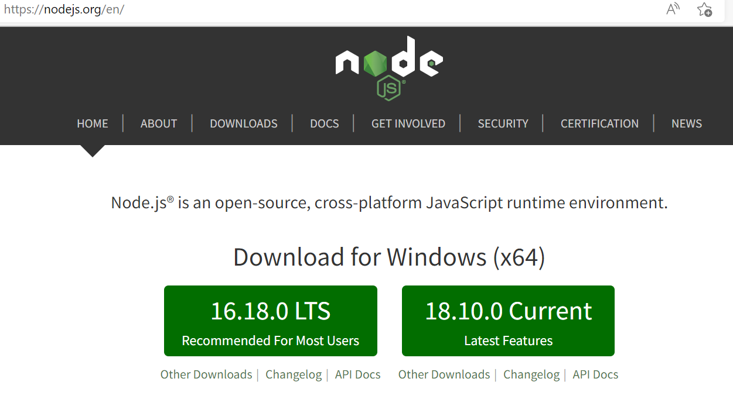

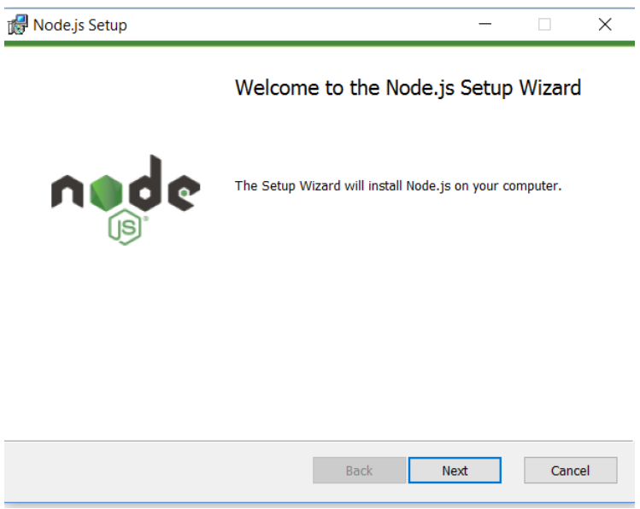

Step :2 -> Click **Next**

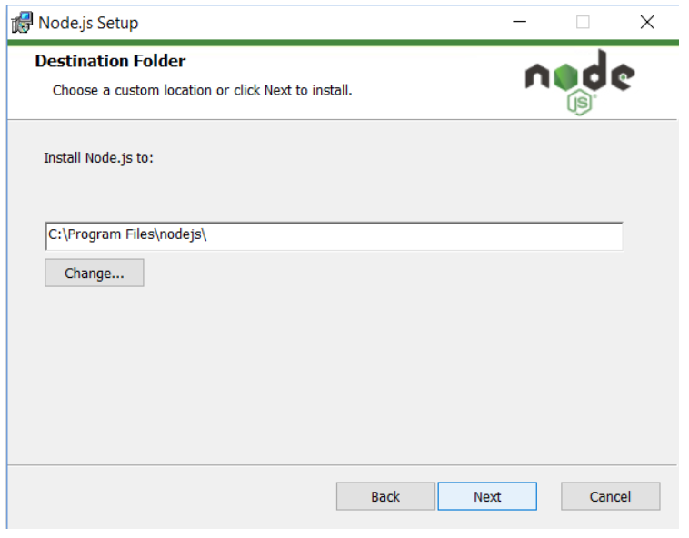

Step :3 -> Click **Next**

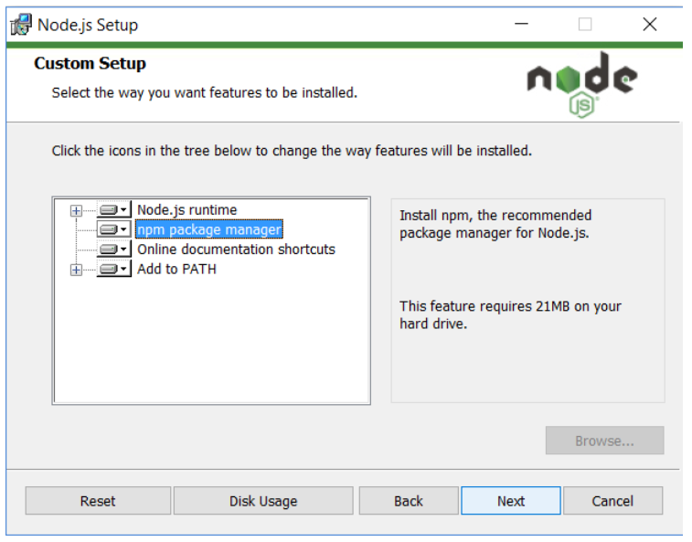

Step : 4 -> Click **Next**

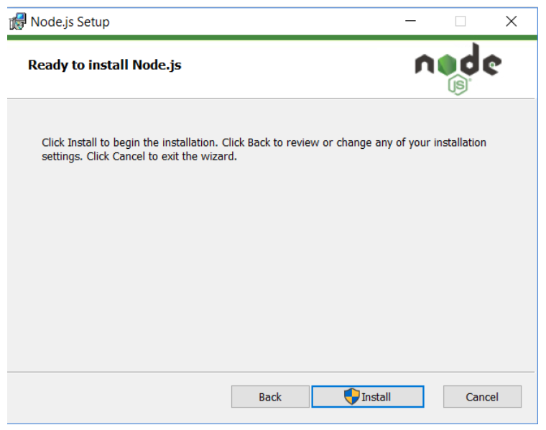

Step :5 -> Click Install

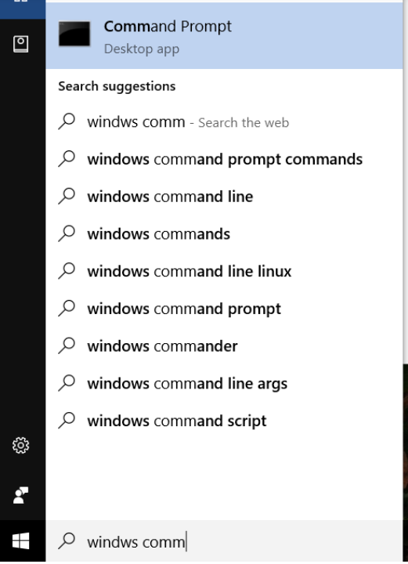

Step :6 -> Go to command prompt

1. To confirm Node installation, type node -v command
2. To confirm NPM installation, type npm -v command

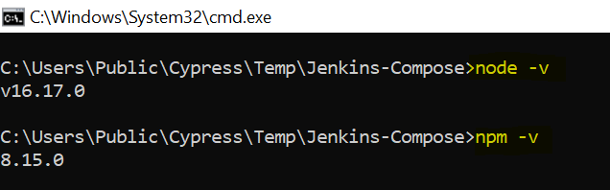

Visual Studio code editor.

To download Visual studio code editor use the URL : <https://code.visualstudio.com/download>

**Open Project:**

Open the project in Visual studio code editor.

**Run Project:**

Open the Terminal in the Visual studio code editor.

Enter below code to run project.

1. npm run test

2. hit enter

**To Run Mochawesome Report:**

Open the Terminal in the Visual studio code editor.

Enter below code to generate mochawesome report.

1. npm run mochawesome:report

2. hit enter

**To Add test case:**

1.Go to the project

2.Under the cypress folder e2e where we can create test cases by click plus symbol

3.We can write test cases under it block

**Cucumber-Report:**

Under the project there will be a cucumber-report.json, just cut and paste it under cucumber-json folder Open the Terminal Enter below code to generate cucumber html report

1. npm run html:report

2. hit enter